Assignment – 12
Group by – 2 Command

- Write a SQL query to calculate the total purchase amount of all orders. Return the total purchase amount.
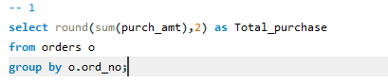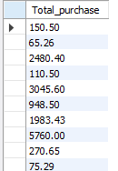
- Write a SQL query to calculate the average purchase amount of all orders. Return average purchase amount.
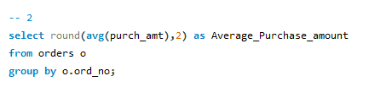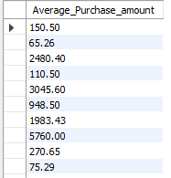
- Write a SQL query that counts the number of unique salespeople. Return the number of salespeople.
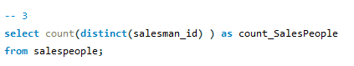
- Write a SQL query to count the number of customers. Return the number of customers.
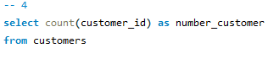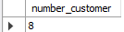

- Write a SQL query to determine the number of customers who received at least one grade for their activity.
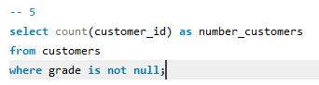
- Write a SQL query to find the maximum purchase amount.
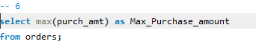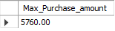
- Write a SQL query to find the minimum purchase amount
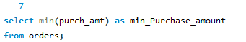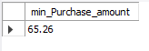
- Write a SQL query to find the highest grade of the customers in each city. Return city, maximum grade.
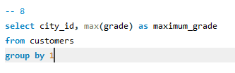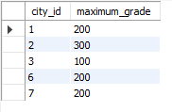
- Write a SQL query to find the highest purchase amount ordered by each customer. Return customer ID, maximum purchase amount.
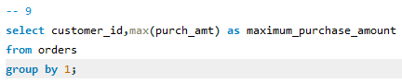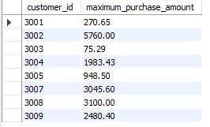
- Write a SQL query to find the highest purchase amount ordered by each customer on a particular date. Return, order date, and highest purchase amount.
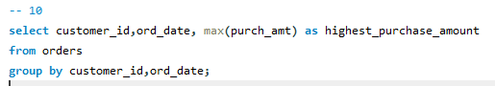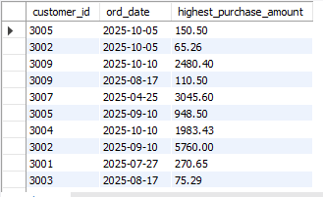
- Write a SQL query to determine the highest purchase amount made by each salesperson on '2012-08-17'. Return salesperson ID, purchase amount
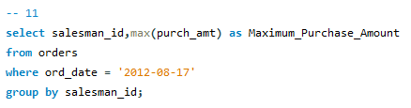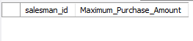
- Write a SQL query to find the highest order (purchase) amount by each customer on a particular order date. Filter the result by the highest order (purchase) amount above 2000.00. Return customer ID, order date, and maximum purchase amount.
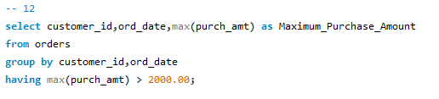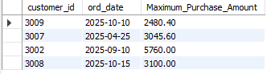
- Write a SQL query to find the maximum order (purchase) amount in the range 2000 - 6000 (Begin and end values are included) by combination of each customer and order date. Return customer ID, order date, and maximum purchase amount.
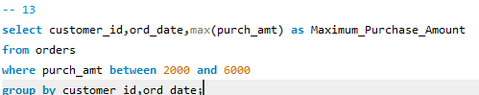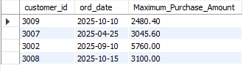
- Write a SQL query to find the maximum order (purchase) amount based on the combination of each customer and order date. Filter the rows for the maximum order (purchase) amount is either 2000, 3000, 5760, or 6000. Return customer ID, order date, and maximum purchase amount.
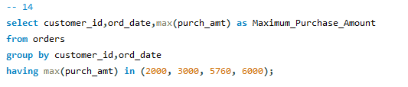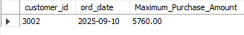
- Write a SQL query to determine the maximum order amount for each customer. The customer ID should be in the range 3002 and 3007(Begin and end values are included). Return customer ID and maximum purchase amount.
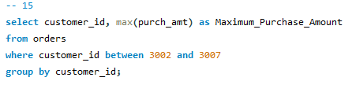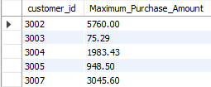

- Write a SQL query to find the maximum order (purchase) amount for each customer. The customer ID should be in the range 3002 and 3007(Begin and end values are included). Filter the rows for the maximum order (purchase) amount that is higher than 1000. Return customer ID and maximum purchase amount.
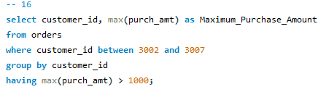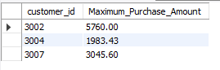
- Write a SQL query to determine the maximum order (purchase) amount generated by each salesperson. Filter the rows for the salesperson ID in the range 5003 and 5008 (Begin and end values are included.). Return the salesperson ID and maximum purchase amount.
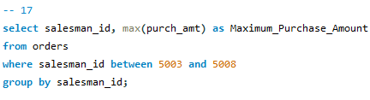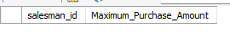
- write a SQL query to count all the orders generated on '2012-08-17'. Return number of orders.
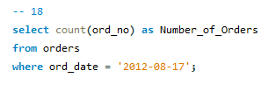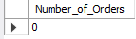
- write a SQL query to count the number of salespeople in a city. Return number of salespeople.
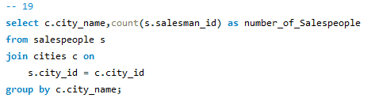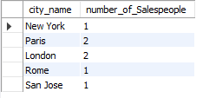

- write a SQL query to count the number of orders based on the combination of each order date and salesperson. Return order date, salesperson id.
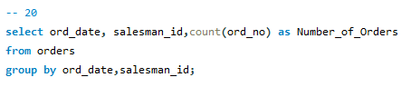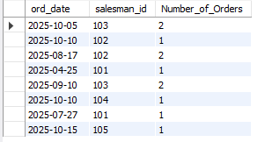
- write a SQL query to calculate the average product price. Return average product price.

- write a SQL query to count the number of products whose price are higher than or equal to 350. Return number of products.

- write a SQL query to compute the average price for unique companies. Return average price and company id.

- write a SQL query to compute the sum of the allotment amount of all departments. Return sum of the allotment amount.
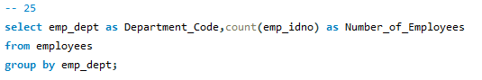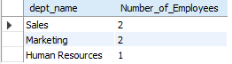
- write a SQL query to count the number of employees in each department. Return department code and number of employees.

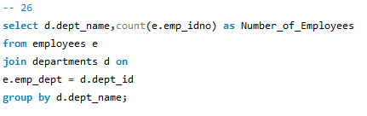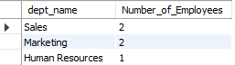

- Find the average salary for each job title in the company.

- List the number of employees in each department.

- Determine the total salary expenditure by each department.

- Compute the maximum salary in each location.

- Calculate the total number of employees in each location

- Display the job titles of employees who work in the same department.

- Determine the number of employees in each job title

- Compute the average salary for employees in each department.

- Find the department names and locations with more than five employees.

- Calculate the total salary for each department and location.

